Course: CIS 130
Assignment: Assignment 5 — Assembly Loops
Student Name: Alejandro Pantoja-Zurita
Date: April 3, 2026

Part 1 — Your MASM Assembly Code
; =========================================================================================
; AUTHOR: ALEJANDRO PANTOJA-ZURITA
; COLLEGE: DELAWARE TECHNICAL COMMUNITY COLLEGE
; COURSE: CIS 130: COMPUTER ORGANIZATION
; INSTRUCTOR: JIN AN
; DATE: APRIL 3, 2026
; PROJECT: ASSIGNMENT 5: ASSEMBLY PROGRAM 1
; NOTES: PROGRAM CREATED TO GET BETTER UNDERSTANDING OF ASSEMBLY PROGRAMMING.
; =========================================================================================

.386 ; Target CPU (32-bit CPU)

.model flat,stdcall

.stack 4096 ; Allocates stack space (4096 bytes) for program.

.data ; Variables are declared past this point

numbers dword 1, 2, 3, 4, 5, 6, 7, 8, 9, 10 ; numbers[] = [1, 2, 3, 4, 5, 6, 7, 8, 9, 10]
sum dword 0 ; variable to store the sum of the values in 'numbers' array. sum = 0.

ExitProcess proto,dwExitCode:dword

.code ; Instructions go past this point

main proc ; Main procedure (function) starts here.

mov ecx, lengthof numbers / 2 ; ecx (Extended Counter Register) = 5 -> LENGTHOF numbers (10) / 2 (# of loops).
; (Value decrements each loop till it gets to 0)

mov esi, 0 ; esi (Extended Source Index) = 0 -> keeps track of indexing while inside loop.
mov eax, 0 ; eax (Extended Acumulator Register) = 0 -> keeps track of the sum while inside loop.

L1: ; Loop created to get sum of array. L1 acts as the label to let program know where loop starts.

add eax, [numbers + esi * TYPE numbers] ; Add the value stored in numbers[index value] to eax. index = esi * TYPE numbers (4)
add esi, 2 ; Increment the value of esi to cycle through array. (esi += 2)

loop L1 ; Let program know to repeat loop again until ecx = 0. ecx automatically decrements each loop.

mov sum, eax ; Move the value stored inside eax to the sum in memory. sum = eax (sum of array.)

invoke ExitProcess,0 ; Tell Operating System to terminate the program.

main endp ; Main procedure (function) ends here.

end main ; Code for "linker", lets program know the entry point is the main procedure (function)

Part 2 — Register Screenshots
- Screenshot 1 — Before Loop Starts
- 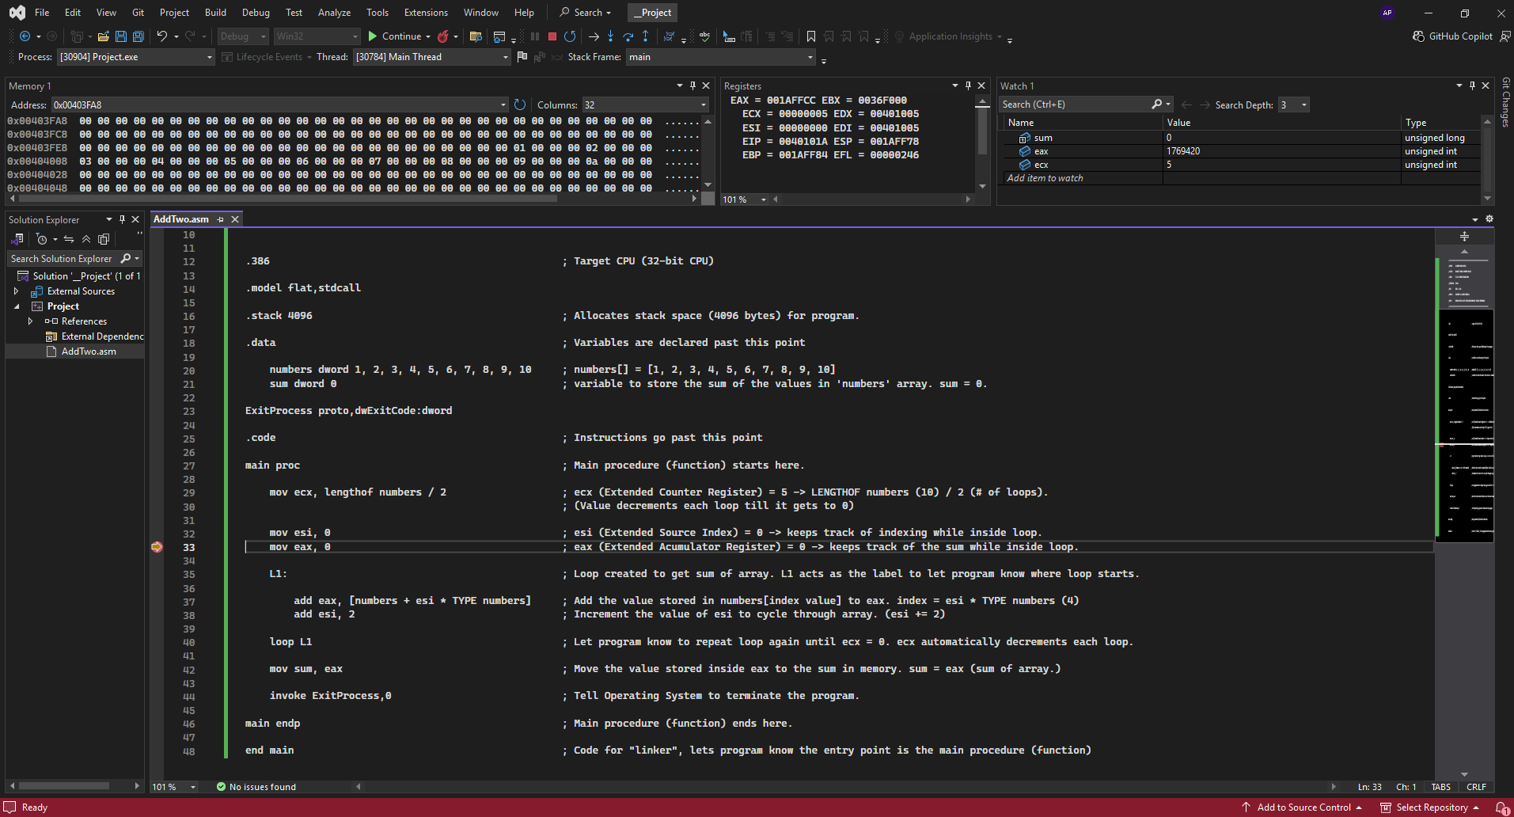Screenshot 2 — Inside the Loop
- 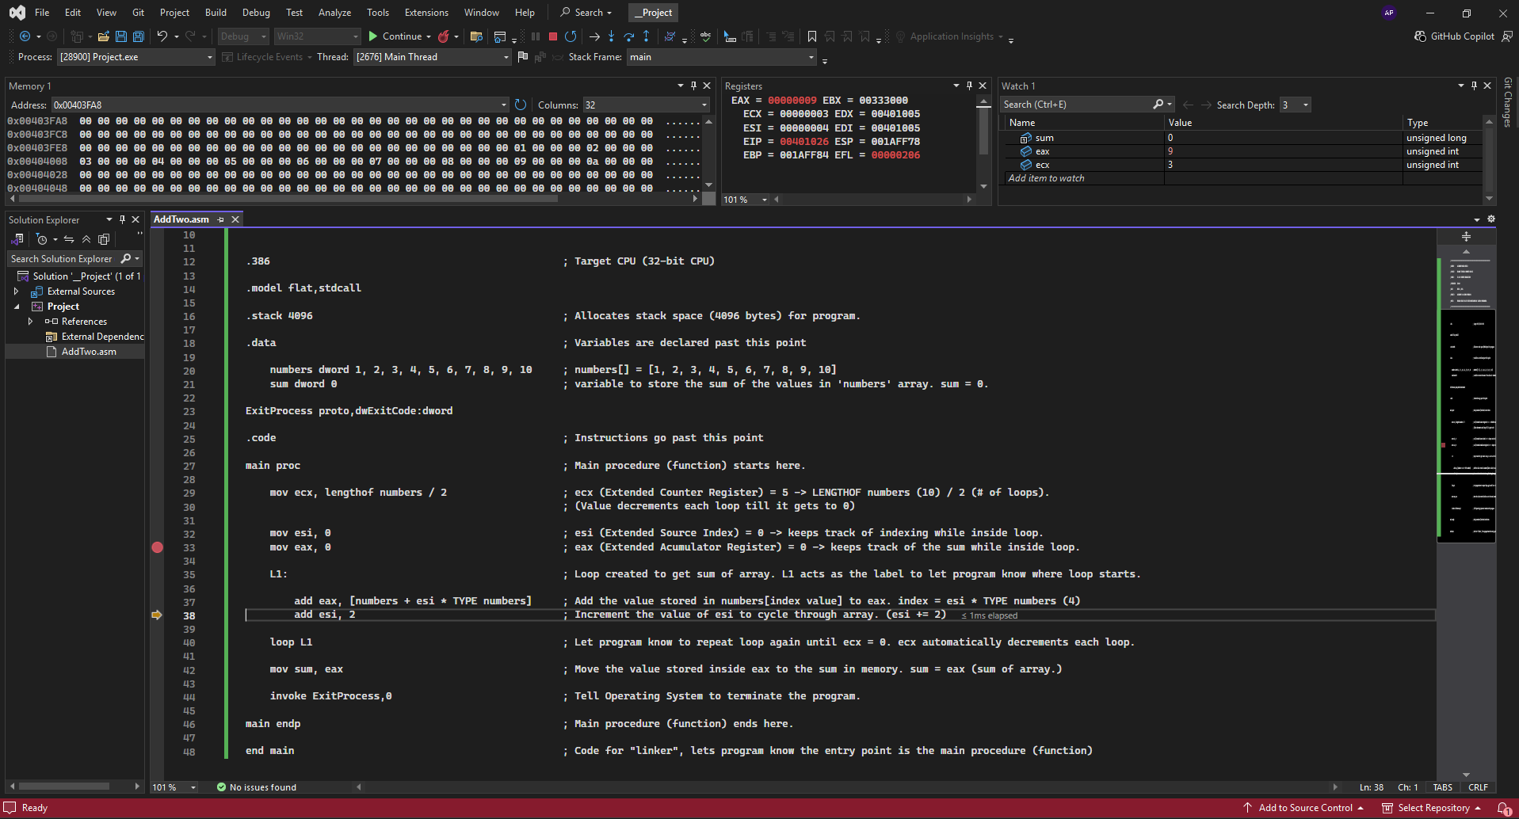Screenshot 3 — After Loop Finishes (final sum should be 25)

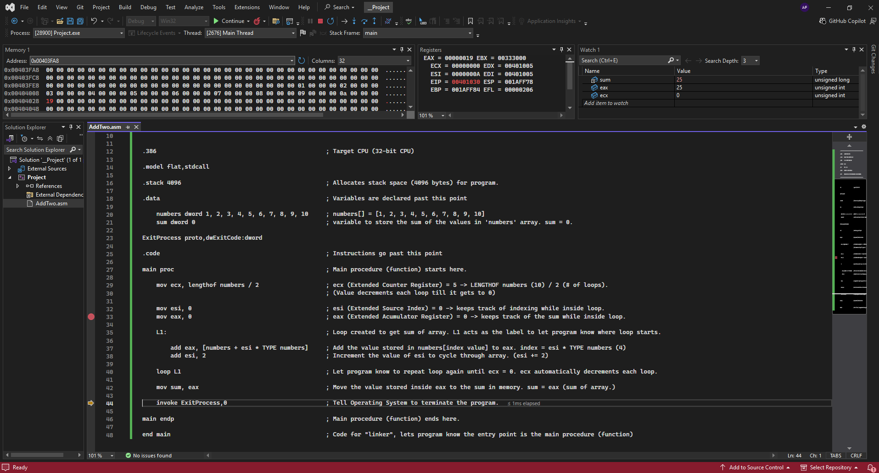Part 3 — Summary Questions
1. Which register did you use as the loop counter, and why?
ecx (Extended Register Counter), this register is used to specifically to keep track of the count while iterating through a loop.
mov ecx, lengthof numbers / 2
; ecx (Extended Counter Register) = 5 -> LENGTHOF numbers (10) / 2 (# of loops).
; (Value decrements each loop till it gets to 0)
2. Explain how you used indexed addressing to access arr[i].
I initialized esi with a value of 0 to access the first variable in the numbers array. While inside the loop I would increment esi by 2 to access every other variable inside the array. Afterwards I would multiply esi by TYPE numbers. This would give me the element size (4). esi * 4 can be used within the loop to get correct indexing for elements while skipping every other element as well. Lastly added the number provided to a dereference numbers array. [numbers + (esi * 4)]. This would give me access to the index, where I would add that value to eax while iterating through the loop.
add eax, [numbers + esi * TYPE numbers]
3. What instruction(s) did you use to increment the loop counter by 2?
add esi, 2 ; Increment the value of esi to cycle through array. (esi += 2)
4. How did you store and update the running sum? Where is the final sum stored?
While the program was running through the loop I used eax to store the sum temporarily.
The final sum is stored in a variable known as “sum”.
mov sum, eax ; Move the value stored inside eax to the sum in memory. sum = eax
5. If the array length changed to 20 elements, would your code still work? Why or why not?
My code would still work with the way I have set, if the task was to continue to add up every other element within the array. I did not hard code the size of the array to a variable. Instead I made sure that the size of the would always be correctly captured using
mov ecx, LENGTHOF numbers / 2
this line item ensure the ecx (Extended Counter Register) always captures the correct about of loops needed to iterate through the array while only worrying about half of the elements. I still need to change the 2 manually if required to skip more elements. There is also line within the loop that also has a value of 2 hardcoded.
add esi, 2 ; Increment the value of esi to cycle through array. (esi += 2)
I would need to make sure both these are manually adjusted in order to ensure the code still works in any scenario.

Part 4 — Student Certification
By typing your name below, you certify that the work submitted in this worksheet represents your own effort and that all screenshots and code reflect your actual program execution.
Signature: _Alejandro Pantoja-Zurita__
Date: __04/03/26________________________

